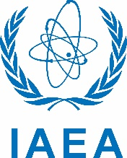

**Multimedia Release Form**

By signing this release form, I hereby grant permission to the International Atomic Energy Agency (IAEA) to edit, use, reproduce, publish and distribute, worldwide and in perpetuity, for all purposes, in any manner and in any medium, the photograph(s) and/or video(s) taken of me by the IAEA on ____/__ /_____(date) in ______________________________________________________ (location including city/town and country).

I hereby release the IAEA from any and all claims in connection with these photograph(s) and/or video(s), including, without limitation, any claims for libel or invasion of privacy.

_________________________________________________________________________________

Name of Person Age (if under 18 years) Date Signature

(if above 18 years)

***IF THE PERSON IS A CHILD UNDER 18 YEARS OF AGE:***

I confirm that I am the legal guardian of the child named above and therefore may grant permission for this multimedia release on behalf of the child:

_________________________________________________________________________________

Name of Legal Guardian Relationship to Child Date Signature of Guardian